Project Design Phase-II
Data Flow Diagram & User Stories

Date | 31 July 2026
Team ID | Vemuri Gayathri
Project Name | Metro Ticket Generating System in ServiceNow
Maximum Marks | 4 Marks

Data Flow Diagrams:
A Data Flow Diagram (DFD) is a traditional visual representation of the information flows within a system. A neat and clear DFD can depict the right amount of the system requirement graphically. It shows how data enters and leaves the system, what changes the information, and where data is stored.
Example: Level 0 DFD

- External Entities:
  - Commuter / Passenger
  - Payment Gateway (UPI / Cards / Wallets)
  - AFC (Automated Fare Collection) Gate Hardware / Scanner
- Central Process: 1.0 Metro Ticket Generating System (ServiceNow Platform)
- Data Flows:
  - Commuter $→$ System: Ticket Request (Origin, Destination, Passenger Count, Journey Type).
  - System $→$ Payment Gateway: Payment Initiation & Amount.
  - Payment Gateway $→$ System: Payment Confirmation Status.
  - System $→$ Commuter: Dynamic QR-Code Ticket (via Service Portal / WhatsApp / Email).
  - Commuter $→$ AFC Gate: Present QR Code.
  - AFC Gate $↔$ System: Real-Time QR Verification Request & Gate Open Signal.

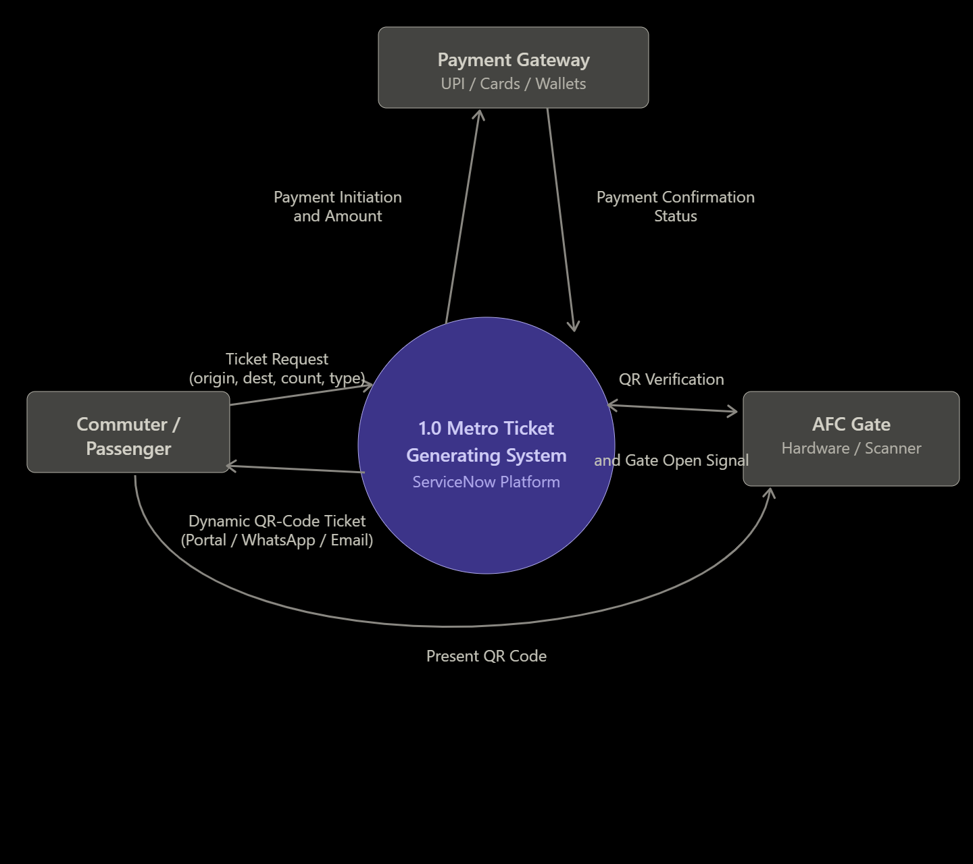
Process ID | Process Name | Data Inputs | Primary Outputs | Connected Data Store
1.1 | User & Ticket Selection | Station Selection (Origin/Destination), Ticket Type | Calculated Fare | D1: Station & Fare Master
1.2 | Payment Processing | Fare Amount, Selected Payment Mode | Payment Token / Confirmation | D2: Transaction Store
1.3 | QR Ticket Generation | Payment Success Event, User ID | Dynamic QR Code, Unique Ticket ID | D3: Active Tickets Store
1.4 | Gate Validation & Entry/Exit | Scanned QR Code Data | Gate Unlock Command, Entry/Exit Status | D3: Active Tickets Store
1.5 | Analytics & Reporting | Entry/Exit Logs, Revenue Data | Passenger Insights & Usage Dashboard | D4: System Analytics

User Stories
Epic 1: Passenger Experience & Ticketing
- User Story 1.1:
  - As a commuter,
  - I want to select my origin and destination stations on a ServiceNow portal/mobile interface,
  - So that I can quickly generate a ticket without standing in physical queues.
  - Acceptance Criteria: Real-time fare calculation, clear station dropdowns, single/return ticket toggle.
- User Story 1.2:
  - As a commuter,
  - I want to receive a dynamic QR code on my phone immediately upon successful payment,
  - So that I can scan it directly at the station entry gate.
  - Acceptance Criteria: Instant delivery, legible QR format, valid entry/exit timestamp constraints.

Epic 2: Payment & Integration
- User Story 2.1:
  - As a commuter,
  - I want to pay for my metro ticket using preferred digital methods (UPI, Credit/Debit card, Wallets),
  - So that I don't need to carry physical cash.
  - Acceptance Criteria: Integration with secure payment APIs, immediate refund triggering on failed transaction attempts.

Epic 3: Operations & Gate Validation
- User Story 3.1:
  - As an AFC gate scanner,
  - I want to validate the QR code against active ticket records in real-time,
  - So that I can grant access to valid passengers and mark the ticket status as "In-Transit" or "Used".
  - Acceptance Criteria: Sub-second response time, rejection of expired or reused QR codes.

Epic 4: Analytics & System Operations
- User Story 4.1:
  - As a transit manager,
  - I want to view live traffic and revenue dashboards using ServiceNow Performance Analytics,
  - So that I can monitor peak travel hours and station passenger throughput.
  - Acceptance Criteria: Real-time visual widgets, passenger flow breakdown by station, daily ticket count summaries.
s

